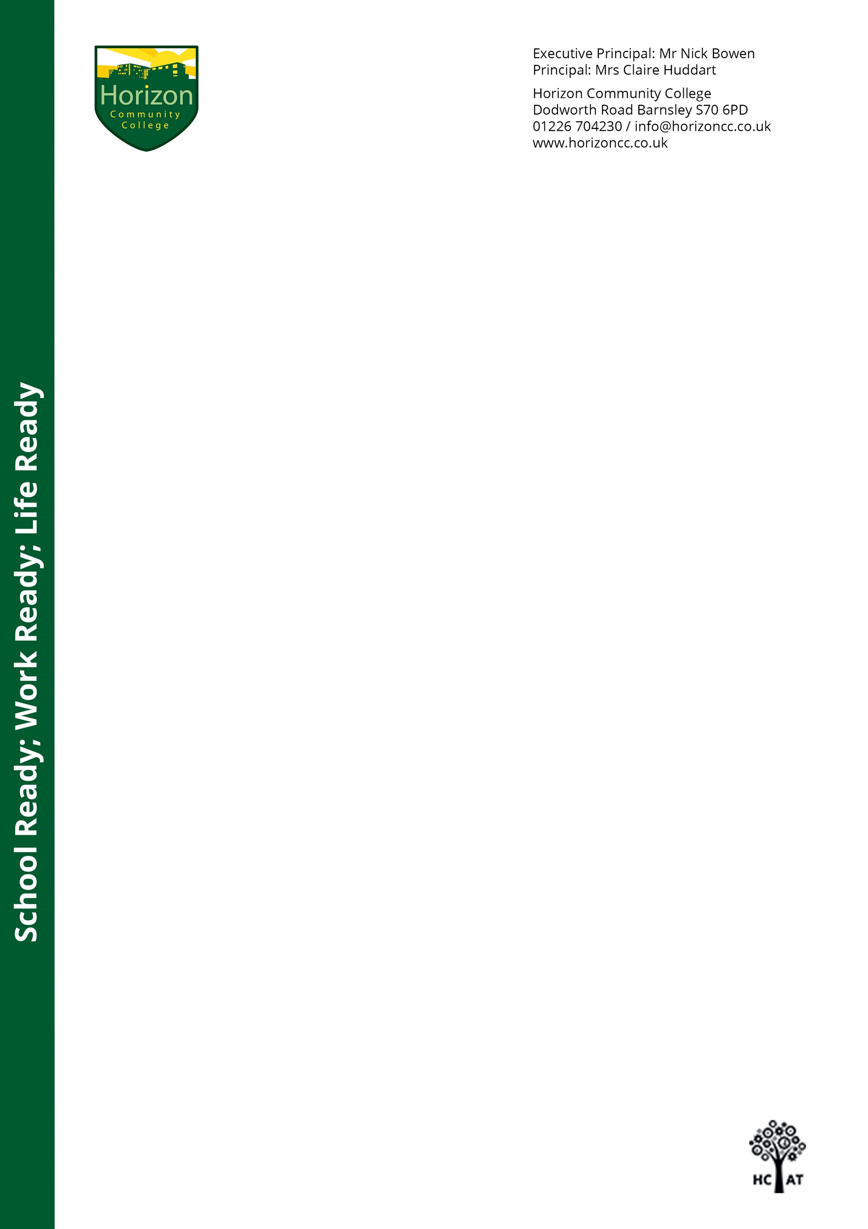

Dear Parents/Carers,

Horizon Community College Open Day

Choosing the right secondary school for your child is a very important and exciting decision.

To help you make the right decision, I am delighted to be able to offer you the opportunity to visit Horizon Community College.

We will be holding an Open Day for Year 6 students and their parents on **Saturday 26th September** between 9am and 3:30pm. This will enable you to speak to staff and visit some of the key areas of the college, including our dedicated Year 7 provision.

This will be a book-able ONLY event due to COVID restrictions and the importance of protecting students, staff and families. As I am sure you will appreciate, we have had to significantly change and scale down how we run this annual event to ensure everyone remains safe.

Please note that bookings will be allocated on a first come, first served basis. We will admit families at 15 minute intervals across the day, with a limited number of families invited into the building at any one time. Unfortunately, we will not be able to allow anyone into the building if you have not pre-booked.

If you would like to book a place on our Open Day, please visit the college website and book through EventBrite. You will find the link at the top of our homepage from **Thursday 17th September at 6pm**. The EventBrite system will also take your details for Track and Trace. You must then bring your ticket on the day to be permitted into college. This ticket will include a QR code which will be scanned on entry to the college building.

To ensure we do keep everyone safe and follow all Government guidelines, please be aware of the following points that we will put into place on Saturday 26th September:

* When booking a place, please limit the number of people in your group and remember, they must be from the same household. We ask for a maximum of 2 adults per family.
* Due to limited slots, please do only book one slot per admission.
* Please arrive at your booked time – we will not be able to admit anyone into the building early or late.
* Face coverings must be worn.
* Please sanitize your hands when you enter the building.
* It is an expectation that social distancing rules are followed at all times.
* Once in the building, you and your family will follow a guided one-way route.
* This route will take you from the college heart-space into the Year 7 area and then into the Sports Hall, where you will have the opportunity to meet staff from our subject areas and SEND.
* Members of our College Leadership Team will be available along the route to answer any questions.
* We anticipate each group will spend approximately 30 minutes in the college building.

If you are not able to book a visit or you do not feel comfortable visiting the college at this time, we have created a dedicated admissions area on the college website [www.horizoncc.co.uk](http://www.horizoncc.co.uk)/admissions, where you will find lots of information which we hope you will find useful and informative.

I would also encourage all prospective parents/carers to watch our engaging and informative ‘Welcome to Horizon’ video, which includes footage of the inside of the college building and presentations from members of College Leadership Team about Horizon’s vision, how students learn in the classroom and how we ensure ‘opportunities for all’. This video can be found within the admissions area of the website or by clicking on the following link: <https://youtu.be/5jDq9Yys6KM>

I very much look forward to welcoming you into the college on the September 26th. In the meantime, if you have any questions please do not hesitate to email [transition@horizoncc.co.uk](mailto:transition@horizoncc.co.uk).

Kind regards,

Mrs C Huddart